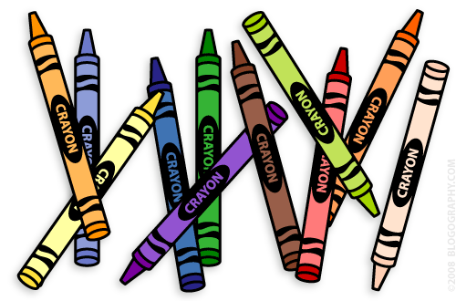**Our 1st Grade Classroom News**

**The Week of Dec. 5th – 9th**

**Email:** [**Lweeks@bluevalleyk12.org**](mailto:Lweeks@bluevalleyk12.org)

**Website:** [**www.bluevalleyk12.org/hes/lweeks**](http://www.bluevalleyk12.org/hes/lweeks)

-If you were thinking about getting me a gift for Christmas and struggling to think of what to get, an idea would be to donate to a local dog shelter and just let me know about it in a card! ☺ I am a HUGE supporter of shelter animals so that would be a present in itself! Some favorite dog shelters of mine are: Unleashed Pet Rescue, Wayside Waifs, KC Pet Project, Rescue K-911, and Great Plains SPCA!

-We are running low on dry erase markers already! If you are able to donate some to our classroom, we would all appreciate it so much! Thanks so much for ALL of the donations you have provided this school year already!

**Important Info**

**Upcoming Events**

**Math Challenge of the Week:**We have been working on skip counting by 2, 5, and 10’s. Quite a few students struggled with counting by 2’s to 50. Practice this with your child and then have them write the numbers down. *For more of a challenge, have your child do this to 120 instead!*   
  
**Reading Challenge of the Week:** We have been working on cause and effect while we read. We talk about what causes different things to happen in the book. Have your child identify something that happened and what caused it to happen. Have them come up with at least 3 different examples of cause and effect while they read. For example:

Cause: Bobby lied to his friend.  
Effect: His friend was mad at him.

Cause: Susie jumped off of her bike while it was moving.  
Effect: She broke her arm.

**Writing Challenge of the Week:**  We have been talking about things we need vs. things we want. Have your child create a list of things they want for the holiday season. Then have them create a list of things they need in order to survive.

**Website of the Week:** [ABCya Interactive 100 chart](http://www.abcya.com/interactive_100_number_chart.htm) is a great resource to go with what we are learning in math recently. Students can color in a 100’s chart by counting by 2’s, 5’s, or 10’s! <http://www.abcya.com/interactive_100_number_chart.htm>

**App of the Week:** [Trading Cards](https://itunes.apple.com/us/app/trading-cards/id555742821?mt=8) is an awesome app that students can create cards based on what they learn from a book/video/etc. For example, a student might read a book about George Washington. They then could create a trading card on this app that describes him. Awesome to use with non-fiction books!

**Dec 6th** Early Release Day

**Dec 20th** ½ day of School

Winter Party

**Dec 21st – Jan 3rd**  No School

**Jan 4th** Dec. Reading Charts Due

**Tech of the Week**

**Challenges of the Week**